Name of Activity: What is this?
Event: | Facilitator: |  | Date:
Open House | DeVault Clevenger |  | 11/13/2019
Overview
This is a Sense In Activity for a group. The facilitator will hand out different items for the group (eyes closed is preferable). Each participant is asked to interact with the item. Each item will have a different texture. Participants will be asked to guess what they are holding—but not say it out loud, until the facilitator processes at the end. Some items may “take” the participant to a place that is calming, but as people are different the item may stir an unpleasant feeling/thought. The facilitator will ask the group about “checking in” with their body as any Sense In activity draws out the connection between our experiences and our body.
Materials Needed | Various items with different textures: stress balls, feathers, shells, felt pieces, toy animals | 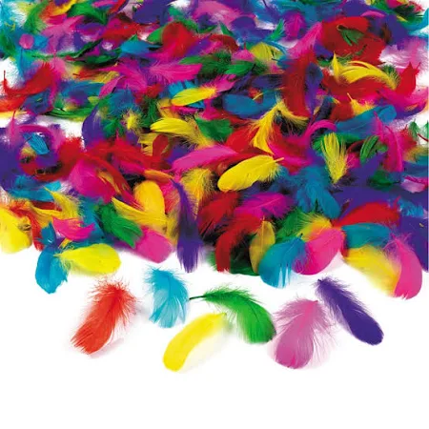
Instructions | Ask participants to close their eyes if they feel comfortable in doing so. Hand out items to the group (do this about 4 times). If you have enough had out the same item to each participant. If not hand out half of one item half the group and half of the other to the second half. When participants have the item in hand, ask them how it feels (soft, hard, warm, cold). Ask: Do they know what their item is? If so, does thinking about the item calm them? Does thinking about the item transport them to another place—a calming place? Ask them to notice how their body is reacting. Remind them that the item may cause unpleasant thoughts/feelings and that they can put the item down if they so wish. Ask all to put their item on the table in front of them and hand out the next item and repeat. After the 4th round, ask participants to open their eyes and look at their items. Process by asking for a few to answer questions. Ask did you know what each item was? Ask is the item calmed or was unpleasant? Ask if they were transported? Tie back in to the body. | 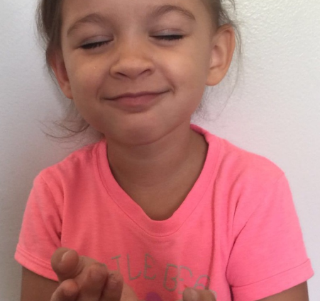
Variations | The 4th item can a piece of wrapped candy. With this variation the idea if to engage all the senses. 1. Feel the texture of the item. 2. Listen to any noise as you touch the item. 3. Smell the item. 4. Open eyes and see the candy. 5. Taste the candy. Tie back in to the body.
Other Resources | https://psychcentral.com/lib/using-the-five-senses-for-anxiety-relief/ | 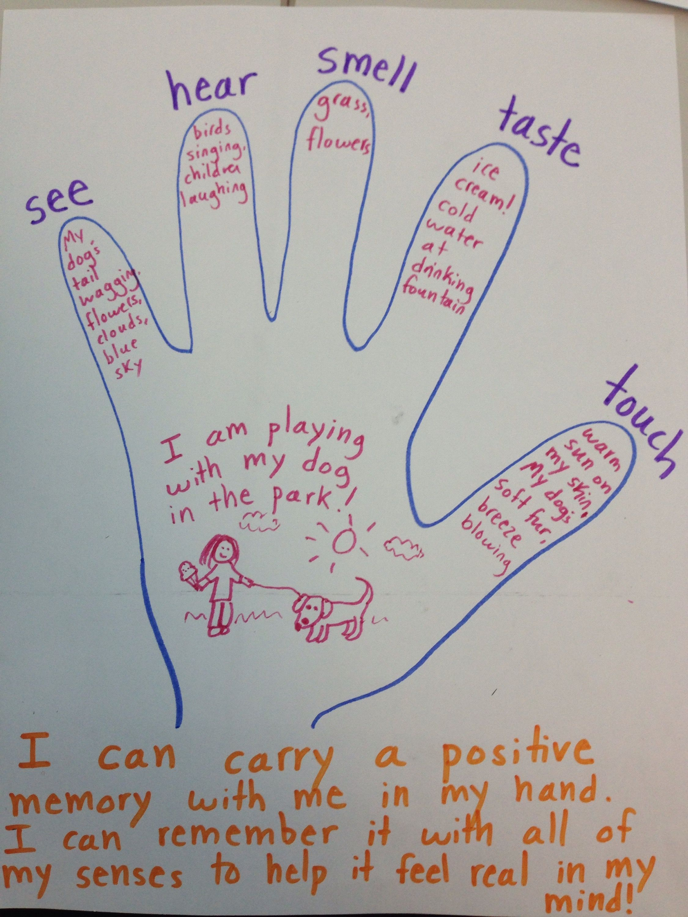
Summary | Type here | Can place graphic here
Notes
Add your notes here.

