Creating the Texture Box
Find as many items with different textures as possible.
Examples are smooth, rough, hard, soft, wet, dry, liquid, solid, light, heavy, warm, cold, lumpy, gritty.
Also find small objects that one can fill and try to identify. Small toys work. Examples are different animals, different known buildings/landmarks across the world, cartoon figures, stress balls, stuffed animals.
Find a box with different compartments so one can organize like objects.
Use the texture box with a child/ren to help them identify items that they would like to create their Calm Down Box or their Self-soothing kit. Or use the texture box with the What Is This? Activity. See photos below for our example of a texture box.
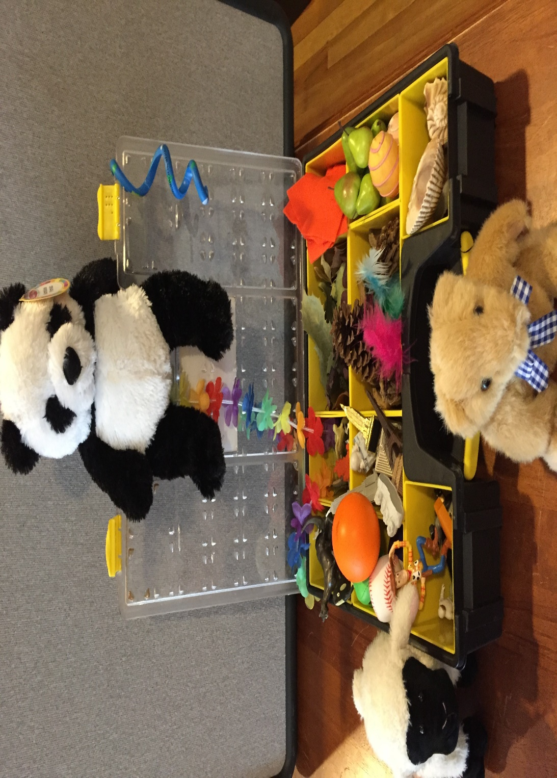
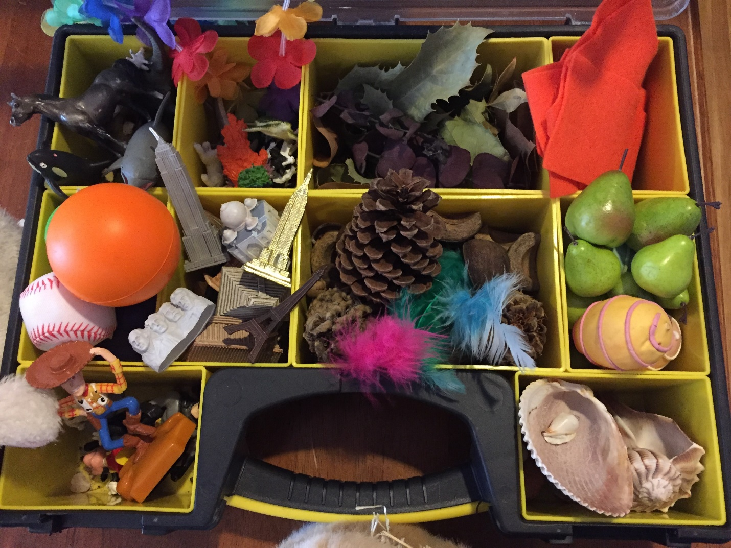
What would you choose for your Calm Down Box or your Self-soothing Kit?
What would you add to the texture box?

