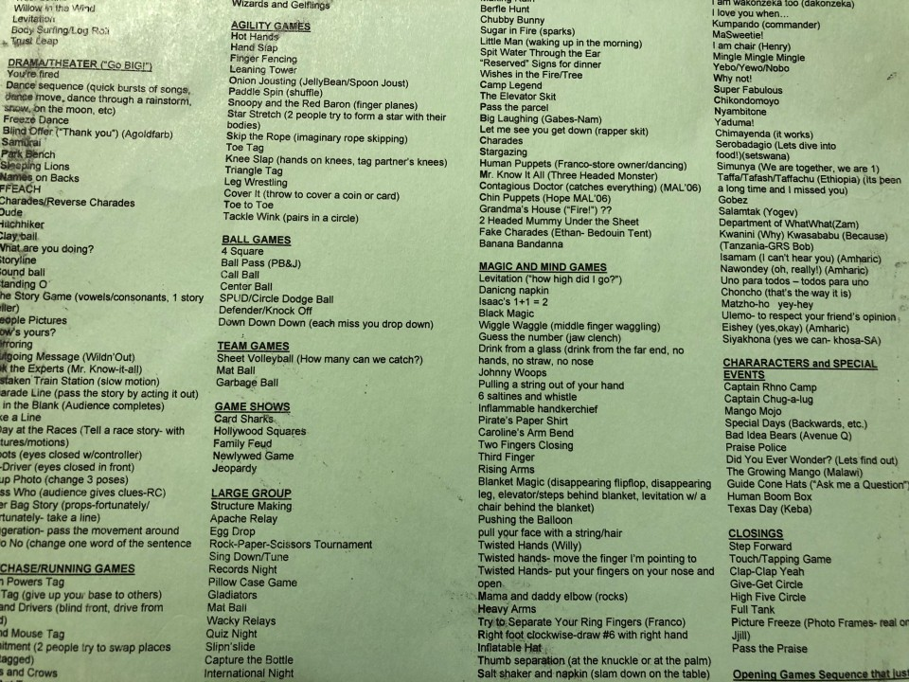

Camp "Stuck-at-Home"​: 7 Great Games From the Edgework Vault
- Published on March 13, 2020

Lou Bergholz

Managing Partner and Founder, Edgework Consulting | Best Selling Author
14 articles Follow
Making the Abrupt Transition from Parent to Activities Leader in the Era of Covid-19
This is part 2 of as many installments as I can write while I try to navigate my business and family life during the Covid-19 pandemic.
As some of you may know, I spent fifteen years consulting to three fantastic organizations, The Hole in the Wall Gang Camp, The Serious Fun Children's Network, and Next Step.
During that time, I had the privilege of facilitating over 70 weekend retreats and helped design and launch residential and day camps in Thailand, Namibia, Ethiopia, and Malawi.
The photo above is a section of a games list I've been carrying around for over 25 years. To anyone who knew me way-back-when at Emma Kaufmann Camp, this list grew out of a ridiculous set of index cards I carried around that was my rolodex of games.
This list of games is 6 font, double-sided and has over 700 games and activities on it. At one point, I could pick any game on the list and teach it on-the-spot. I'm a little rusty these days, but I did go through it in the hopes of finding some unique games that parents can add to the many wonderful lists that have begun to circulate since the large-scale school closings have taken effect here in the US.
Records Night: Take whatever materials you have around your home, and invent ways to set records with the events (This is the precursor to "Minute to Win It."). Discus toss with a paper plate, how many times can you flip a penny to land heads in a row, or tallest tower with playing cards. Even more fun: reveal an item (such as a stack of post-it notes), and challenge each other to invent the activity and the record to break.
Big Board Bingo: Almost every game is better when its played faster, or in this case, bigger. Using butcher paper or even taping smaller sheets of paper together, create giant bingo boards. Then, have each child decide what items they want to use to cover the spaces: toys, stuffed animals, school books, etc.
Sing Down: Choose a word (sun, love, heart, blue, etc.). Challenge your kids to try to come up with as many songs that have this word in the song title or lyric. Then, take turns singing a song until all the lists are out.
60 Seconds-25 Words: Take turns trying to name 25 words that all start with the same letter. No proper names or places, and you can't pluralize (turn, turns). This is much easier said than done!
Rock-Paper-Scissor-Flour: What can be better than a game of total chance that ends with one person sticking their face into a bowl of flour?! Check out the game here: RPS Flour
Magazine Scavenger Hunt: Give each person a magazine. Shout out things for them to search for in their magazine- a person in a park, a dog, a boat, etc.). The first person to find it wins a point for that round.
The Pillowcase Game: I might be saving the best for last! Stuff a pillow case with clothes and then one coveted prize (an individually wrapped snack for example!). Players take turns rolling dice (real dice or even small dice made from cardboard will work). If someone gets doubles, they can then try to retrieve the prize from the pillowcase. However, first they must put on a pair of oven mitts and a hat or glasses and search in the pillowcase using this equipment. If someone else rolls doubles they shout "Freeze! and then they can have a try- always putting on the props first!

Report this

Published by

Lou Bergholz
Managing Partner and Founder, Edgework Consulting | Best Selling Author
Published • 1w
14 articlesFollow
Camp Stuck-at-Home continues! Digging into the Edgework vault for some of my favorite games to play for what may be a long time hanging out as a family. hashtag#parenting hashtag#gamesforkids hashtag#playtime hashtag#resilience hashtag#mentalhealth hashtag#qualitytime

