It’s important for young children to listen to and repeat parts of simple and repetitive songs and finger plays. Try the finger plays below to help build vocabulary in your toddler and preschoolers.
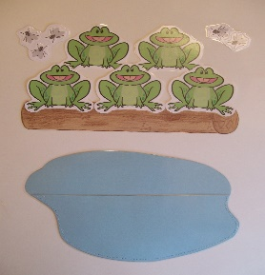
Five Green, Speckled Frogs
Five green and speckled frogs (hold up five fingers)
Sat on a speckled log,
Eating the most delicious bugs,
Yum, yum! (rub tummy with other hand)
One jumped into the pool (tuck one finger down)
Where it was nice and cool,
Then there were four green speckled frogs,
Glub, glub!
Four green and speckled frogs…
(Continue until there are no speckled frogs on the log).
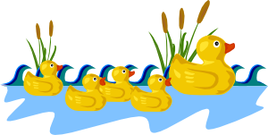
Five Little Ducks
Five little ducks went swimming one day (hold up five fingers)
Over the hills and far away (hold arm across body and tuck fingers behind shoulder on the opposite side of the body)
Mother duck said, “Quack, quack, quack, quack” (use other hand to make a mother duck beak and open and close hand to quack)
But only four little ducks came back (bring first hand back to the front with four fingers showing
Continue until no little ducks come back then:
Mother duck went out one day
Over the hillls and far away
Mother duck said “quack, quack, quack, quack”
And all of those five little ducks came back.

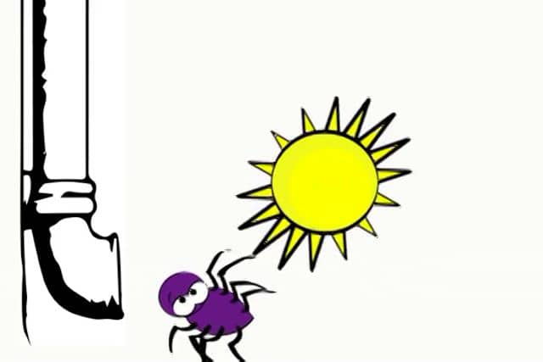
Itsy Bitsy Spider - Fingerplay (movements)
The itsy bitsy spider went up the water spout.
(Touch the thumb of one hand to the index finger of the other hand. Then touch the index finger to the thumb of the other hand. Do it over again while lifting your hands up.)
Down came the rain,
(Bring your hands down. While you are doing this, wiggle your fingers to simulate rain.)
and washed the spider out.
(Sweep your hands away from one another while hand palms are pointing towards the floor.)
Up came the sun, and dried up all the rain,
(Form a circle with your hands (sun), and rise your hands (the sun is rising).
and the itsy bitsy spider went up the spout again.
(Repeat step one.)

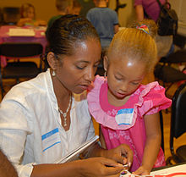
Its important for children to be able to describe familiar people, places, things and events. For toddlers, provide baby dolls, toy telephones, play dishes and food. Spend quality time with them playing house such as pretending to cook, taking care of the baby and talking on the telephone. As you play with them use lots of descriptive words as you talk about what you are doing. For example, “I’m going to take care of the baby. I’ve got to give her a bottle. She’s crying because she’s hungry. Let me check to make sure it’s not too warm.” Spending this quality time interacting with your toddler will give your child the opportunity to hear familiar events and things described.
For preschoolers, take time to spend with them in rich conversations. Ask them to describe what they are doing as they’re playing. Ask them to tell you about their day. As you ask them questions make sure you use open-ended questions to encourage the child to give more than yes or no answers and to go in more detail. For example,

Parent: John, tell me what you did today.
John: I played outside.
Parent: What did you do outside?
John: I played ball.
Parent: Tell me how to play ball.

The idea is to involve the child in longer conversations building their vocabulary skills.

