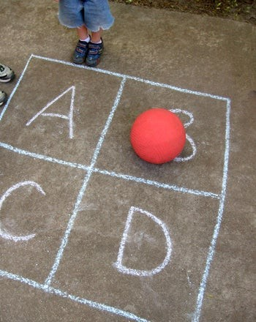

Camp Stuck-At-Home: Don’t Forget To Include Gym In Your Family’s Covid 19 Daily Schedule
- Published on March 16, 2020

Lou Bergholz

Managing Partner and Founder, Edgework Consulting | Best Selling Author
16 articles Follow

Making the Abrupt Transition from Parent to Phys. Ed Teacher and Coach in the Era of Covid-19
This is part 4 of as many installments as I can write while I try to navigate my business and family life during the Covid-19 pandemic.
In 2012 I set a personal facilitation record. I delivered 20 days of training in 20 days. I was working in Gaza at the time (Shout out to the amazing Mentors from Eye to the Future!) and the only way we could fit the launch of this part of our project in to everyone’s schedules was if I could pull off five 4-day trainings in a row, without a break. On top of that, for security reasons, I couldn’t leave the hotel the entire time.
There was no gym in the hotel, so I brought a set of workout DVDS. For anyone who was on the “Shaun T Bus” a few years back, you will recall that Tanya was the one to beat in these videos. I set my sights on besting her in every exercise. I don’t think I beat her even once, but wow, did those workouts get me through an intense trip.
I’m certain, as you’re settling in to your Covid-19 family schedule, you’ve thought about active periods in your children’s day that complement study time, screen time, and chill time.
However, I’m talking about gym time, and when I say gym, I mean GYM. Don’t think light recreation that preserves the fragile objects in your living room. I’m talking about clearing the furniture, rolling up the rug, putting on some choice beats, and having a full-on family workout or competitive play.
We know physical activity is good for our health, but it’s important to examine it more closely. It can serve such a crucial purpose during this time intense time period.
- It Creates Perspective: The shift in chemicals in your body, specifically, the increase in “soothing chemicals” such as serotonin, dopamine and norepinephrine, helps recalibrate your negative stress response, and it literally gives you more clarity and helps you see the bigger picture. You can shift your mood directly from vigorous exercise.
- It Helps With Focus And Learning: Take a page from the many great teachers who know that frequent activity breaks help students focus. Then, take it a step further, and leverage a longer high activity period to drive focus in other parts of the day.
- It Makes Your Brain More Resilient: “Physical activity reorganizes the brain so that its response to stress is reduced and anxiety, is less likely to interfere in normal brain function…” writes Morgan Kelly from Princeton University. We can literally increase our resilience to pressure and stress by exercising regularly.
- It Drives Conversation: We can feel mentally and emotionally unstuck after a workout or intense period of physical activity. We reconsider our views and feel more equilibrium. This can be an ideal time to explore a deeper conversation topic.
- It’s So Good For Sleep: Physical activity can help with rumination and create a calmer state for your body and your mind. I know sleep is not coming easy for many people right now, including your children. Consider whether amping up gym time could help with their (and your) sleep.
We all need these benefits right now, whether we’re 15 months old (like my daughter), 4 years old, 8 years old, 16 years old, 35 years old or 70 years old. The NY Times ran a great article about giving children more screen time during this crisis and though I wholeheartedly agree on easing up on the screen time rules, I also think that it’s prime time to lean in to sweaty, heart-pumping, muscle-straining activities every day. And the sooner the better.
Be sure to include FAMILY GYM in your daily schedule!
My favorite thing about intense physical activity: If you play just about anything fast enough, long enough or hard enough, it can challenge you physically. Here a few of my favorites:
- Four Square: You can play this in almost any open space. Use tape or chalk to mark the squares. If you don’t have a kickball or a soccer ball, any size ball will do. The smaller the ball the more agility you may need. You can even play “tiny four square” on a kitchen table.
- Clipboard Volleyball: Each person holds a clipboard (or a piece of cardboard, or even a book or magazine). Crumble up a ball of paper and try to hit it in the air. Count how many times you can keep it in the air or put a piece of tape across the room and play teams.
- Record Breakers: Create challenges that you can set records for and then try to beat- for endurance, speed, agility, strength, etc. How long can you lean against a wall in a squat position: How many burpees can you do in 60 seconds. How many times can you jump rope in 30 seconds? How long can you keep three balloons in the air?
- Interval Workouts: There are videos for children and you could go hard core, or super hard core with Shaun T!
- Dance Challenges: Take one of these amazing family dances and practice it until your family has the routine perfected!
Set up a tracker for your family gym goals, as individuals and as a family. Post personal bests. Schedule training and competition time. Making the results of your gym time public can help provide one more thing to look forward to each day.
If you’re missing watching professional and college sports, then it’s time to create your very own March Madness tournament. You could even compete against other families virtually and see which family emerges as the local, regional, or even national champion!

